Request for Proposal
Ethernet Cabling Installation
4870 Clark Rd, Ypsilanti, MI 48197

Washtenaw Intermediate School District

The Washtenaw Intermediate School District is soliciting proposals from qualified contractors for the installation of CAT6A Ethernet cabling at our leased facility located at 4870 Clark Road, Ypsilanti, MI 48197. Sealed proposals will be due on Friday, May 30, 2025 by 10:00 a.m. EST, after which time proposals will be opened and read aloud. All proposals will then be reviewed and considered. Proposals are to be delivered to:

Tyler LaTendresse, Assistant Director of Technology and Data Services
Washtenaw Intermediate School District
1819 S. Wagner Road
Ann Arbor, MI 48103

Interested parties are highly encouraged, but not required, to attend a pre-bid meeting and walk-through, which will be held at 4870 Clark Road, Ypsilanti, MI 48197, on Monday, May 19, 2025, at 9:00 a.m.

Envelopes containing proposals must be sealed and clearly marked “Clark Road Ethernet Cabling Installation – Do Not Open” with the name and return address of the vendor on the outside of the envelope. One signed original and two copies of the proposal shall be submitted.

Electronic bids will also be accepted. Electronic bids have the same submission deadline and must be sent by email to tlatendresse@washtenawisd.org with the subject line, “[Vendor Name] – Proposal Submission for Ethernet Cabling Installation.”

Questions regarding the Request for Proposal must be directed via email during the identified “Question Period” per the schedule below to: tlatendresse@washtenawisd.org.

ALL PARTIES WISHING TO RESPOND TO THIS REQUEST FOR PROPOSAL SHALL TAKE NOTICE OF INSTRUCTIONS TO BIDDERS.

Request for Proposal Issued May 12, 2025
Pre-Proposal Meeting & Walk Thru #1 May 19, 2025, at 9:00 a.m.
RFI Deadline May 21, 2025
Clarification answers posted May 22, 2025
Proposal Deadline/ Submissions Due May 30, 2025, by 10:00 a.m.
Board of Ed Recommendation June 10, 2025
Award notice (tentative) June 11, 2025

Hard copies of this RFP will not be provided at the pre-proposal meeting

Request for Proposal:
Ethernet Cabling Installation

DEFINITIONS
The District refers to the Washtenaw Intermediate School District.

Vendor/Bidder/Contractor/Proposer refers to all recipients/potential respondents of this Request.

Request/Proposal refers to the entire process, including the request, response, special provisions, specifications and/or requirements.

RFP refers to the Request for Proposal document in its entirety.

PRE-PROPOSAL MEETING
The purpose of the pre-proposal meeting will be to provide an overview of the District’s request, answer any questions regarding the RFP specifications, and provide a guided tour of the facilities. Vendors interested in submitting a proposal are encouraged to have an authorized representative in attendance at the pre-proposal meeting. Attendees must sign in at the pre-proposal meeting.

RESERVATION OF RIGHTS
The District reserves the right, in its sole and absolute discretion, to accept or reject, in whole or in part, any or all Proposals with or without cause. The District also reserves the right to waive any irregularities or informalities in the RFP process or any proposal. The contract may be awarded to the vendor(s) whose proposal(s) the District determines, in its judgment, to be in the best interest of the District, and not necessarily to the lowest-priced proposal. The District reserves the right to request additional information or clarification from any or all vendors as well as reserves the right to negotiate with the vendor(s) regarding their proposals. The District reserves the right to award the contract in parts or in whole and may award the contract to more than one vendor.

The District reserves the right to waive any informalities, irregularities or technical defects in proposals, and unless otherwise specified by the District, to accept any item or groups of items in the proposal, as may be in the best interest of the District. The District retains the right to award the contract(s) in part or in whole, as may be in the best interest of the District. The District retains the right to qualify or disqualify vendors on the basis of available information pertaining to their service and/or suitability of the services proposed.

Any decision made by the District, including the contractor selection, shall be final.

REQUEST CLARIFICATION
A pre-proposal meeting as well as a specified period for questions has been established and defined within this request for proposal. Any questions related to interpretation of the request, the scope of services or the proposal process shall be addressed as indicated in ample time within the period set.

Questions regarding this request should be directed in writing, via email only, to Tyler LaTendresse, WISD Assistant Director of Technology and Data Services, at tlatendresse@washtenawisd.org as specified before the end of the deadline for questions as posted within the document and request schedule.

If applicable, answers citing the question(s) asked, but not identifying the questioner, will be posted to the WISD web site if deemed relevant by the District and made available to all vendors as listed at the pre-proposal meeting.

BID PREPARATION AND RELATED COSTS
All costs associated with the presentation of the proposal and any supplemental information shall be borne solely by the vendor and shall not be passed on to the District under any circumstances. The District reserves the right to request clarification of information and to request additional information from any or all vendors.

Vendors may submit their proposals either in hard copy or electronically via email. For email submissions, proposals must be submitted in PDF format and must include a signature from an authorized representative of the proposer’s firm. The signed proposal should be attached to an email with a subject line clearly stating the vendor’s name and the project title (e.g., [Vendor Name] – Proposal Submission for Ethernet Cabling Installation). Proposals must be sent to tlatendresse@washtenawisd.org by the submission deadline. A confirmation of receipt will be provided by the District via return email.

For vendors choosing to submit hard copies, one original proposal—hand-signed by an authorized member of the proposer’s firm—must be provided, along with two additional copies. The original copy must be clearly identified as such. All proposals, whether submitted electronically or in hard copy, must be completed using the Proposal Forms included within this RFP. No oral or facsimile submissions will be accepted.

VENDOR RESPONSIBILITY
Vendors are expected to be thoroughly familiar with all specifications and requirements of this Request and to provide proposals using the specific forms as provided within the Request for Proposal. Failure or omission to examine any relevant form, article, site or document will not relieve a vendor from any obligation regarding this Request. If, at any time, the District discovers deviations in a response that are not identified, the vendor may be subject to disqualification from consideration or cancellation of contract.

Each proposer, by submitting its proposal, releases the District from any and all claims arising out of, and related to, the RFP process and selection of a vendor or vendors.

GENERAL CONSIDERATIONS
Proposals received after the time and date specified, whether delivered or mailed, will not be considered and will be returned unopened. The timely submission of a proposal response rests entirely with the Vendor. Delays resulting from postal handling or for any other reason will not extend the timeline for response.

As a result of this request, vendors may be invited for an interview for further presentation and clarification of their services.

The vendor(s) to whom an award is made will be notified at the earliest possible date. The tentative acceptance of the Proposal and award of the contract will be by a notice in writing either via mail or email. All prices proposed by the Vendor must be firm for 90 days from the due date of the proposal. If, for some reason, agreement with the selected vendor cannot be reached to the satisfaction of the District, negotiations may begin with another vendor within fourteen days after the initial finalist vendor selection.

PREPARATION OF PROPOSALS
To facilitate proposal preparation, a copy of this proposal in .PDF format may be obtained and downloaded from our website, https://washtenawisd.org; “Services,” “Business Services,” “Bids.”

If erasures or other changes appear on the proposal forms, each erasure or change must be initialed by the person signing the proposal.

Any documents intended to supplement or deviate from the express requirements of this proposal solicitation may result in rejection of that proposal. Any forms and contracts the vendor proposes to include as part of any agreement resulting from this Request between the Vendor and the District must be submitted as part of the proposal response. Any forms and contracts not submitted as part of the proposal and subsequently presented for inclusion may be rejected by the District. This requirement includes, but is not limited to, the following types of documents: contracts, licensing agreements, maintenance contracts, and system support agreements.

Proposals must be submitted (mailed, shipped, hand-delivered, emailed) to the Contact (Tyler LaTendresse, Assistant Director of Technology and Data Services, 1819 S. Wagner Road, Ann Arbor, MI 48103) as listed in the instructions to bidders.

MODIFICATION OR WITHDRAWAL OF PROPOSALS
A proposal that is in the possession of the Contact may be altered only by letter, email, or fax transmission bearing the signature or name of the person authorized for proposing, provided the alteration is received prior to the deadline for all proposals. An email or facsimile may not reveal the proposal price but could indicate an addition, subtraction, or other change in the proposal.

A proposal that is in the possession of the Contact may be withdrawn by the vendor in person or by written request up to the time of the proposal opening. Proposals may not be withdrawn after the proposal opening.

PEFORMANCE – FORCE MAJEURE
Successful vendors shall be excused from performance hereunder during the time and to the extent that vendor is prevented from obtaining, delivering, or performing in the customary manner by acts of God, fire, war, loss or shortage of transportation facilities, lockout or commandeering of raw materials, products, plants or facilities by the government. Vendor shall provide the District substantiating evidence that non-performance is due to other than fault or negligence on their part.

RESOLUTION OF DISPUTES
Any issues or provisions of the contract in dispute between the District and the vendor, which, in the judgment of either party to the contract may materially affect the performance of such party, shall be reduced to writing by both parties and delivered to the Assistant Superintendent, Administrative and Support Services. The District and the contractor shall promptly, thereafter, negotiate in good faith and use every reasonable effort to resolve such dispute in a mutually satisfactory manner.

ESCALATION
Vendors shall provide a detailed description, including contact titles and information as well as anticipated timeline of response, of their procedure for resolution of unsatisfactory issues with service.

CONFLICT OF INTEREST
Vendor warrants it has no interest and shall acquire no interest that would directly or indirectly conflict in any manner or degree with the performance of this proposal.

NON-COLLUSION
The vendor and the undersigned of any proposal certifies that their proposal has not been made or prepared in collusion or cooperation with any other proposing vendor, or representative thereof, and the prices, terms, or conditions of the proposal have not been communicated by or on behalf of the vendor to any other proposing vendor or potential vendor and will not be so communicated to any other vendor or potential vendor prior to the official opening of the proposals. This certification may be treated for all purposes as if it were a sworn statement made under oath, subject to the penalties of perjury

INTEGRATION
All Proposal solicitation documents, vendor’s response to each solicitation, all correspondence and addenda contain the entire understanding between the parties and any additions or modifications hereto may only be made in writing executed by both parties.

LAWS TO BE OBSERVED
The successful vendor shall keep fully informed on all federal and state laws, all local bylaws, regulations and all orders and decrees of bodies or tribunals having any jurisdiction or authority which in any manner affect those engaged or employed on the work or which in any way affect the ordinances, regulations, orders and decrees in force at the time of award. The successful vendor shall protect and indemnify the District and its representatives against any claim or liability arising from or based on the violation of any such law, bylaw, ordinance, regulation order or decree whether by himself or by his employee(s). No extension of time or additional payment be made for loss of time or disruption of work caused by any actions against the successful vendor for any of the above reasons.

The parties expressly agree and understand that the provider is not an employee or agent of the District in any sense but is a sole independent contractor.

DISCRIMINATION
The District hereby notifies all Vendors it will affirmatively ensure that, in any contract entered into pursuant to this advertisement, minority business enterprises will be afforded full opportunity to submit Proposals in response to this Request and will not be discriminated against on the grounds of race, religion, color, sex, height, weight, handicap, marital status, national origin, or ancestry in consideration of an award. Vendor hereby agrees that should he/she be awarded this contract, Vendor will not discriminate against any person who performs work thereunder because of race, religion, color, sex, height, weight, handicap, marital status, national origin, or ancestry.

IMMIGRATION REFORM AND CONTROL ACT OF 1986
By submitting their Proposal, Vendors certify that they do not and will not during the performance of this contract employ illegal alien workers or otherwise violate the provisions of the Federal Immigration Reform and Control Act of 1986.

SUBSTANCE FREE ENVIRONMENT
The use of tobacco, vaping, drugs or alcohol is prohibited in all District buildings, vehicles, and on the grounds of all District facilities.

FREEDOM OF INFORMATION ACT
Information submitted in vendor proposals becomes public information and, as such, is subject to public disclosure and review under the Michigan Freedom of Information Act. Information contained in the Vendor’s proposal which is company-confidential must be clearly identified in the Proposal

GOVERNING LAW
The laws of the State of Michigan shall govern the validity, construction, and effect of this contract and all extensions and/or modifications. Michigan law shall govern regardless of any language in any attachment or other document that the Vendor may propose.

SEVERABILITY
Should any provision of this contract be declared to be invalid by any court of competent jurisdiction, such provisions shall be severed and shall not affect the validity of the remaining provisions of this contract.

INSURANCE COVERAGE
The Vendor, at its expense, must maintain during the terms of any subsequent contract the following minimum levels of insurance coverage:
- Professional Liability Insurance with minimum limits of $1 million per occurrence and $1 million aggregate.
- Workers Compensation Insurance which meets Michigan statutory requirements.
- Comprehensive General Liability Insurance with minimum limits of bodily injury of $500,000 per person and $1 million aggregate and with minimum limits for property damage of $500,000 each occurrence and $1 million aggregate.
The Vendor shall indemnify and save harmless the District, its officers and employees from all suits, actions, or claims of any character brought because of injuries or damage received or sustained by any person, persons, or property; on account of the operations of the said Vendor, its agents, servants, or subcontractors; or on account of or in consequence of any neglect in safeguarding the work.

TERMINATION
Subject to the provision below, the contract may be terminated by the District upon thirty (30) days advance written notice to the other party; but if any work or service hereunder is in progress but not completed as of the date of termination, then this contract may be extended upon written approval of the District until said work or services are completed and accepted.

Termination for Cause: Termination by the District for cause, default, unsatisfactory performance or negligence on the part of the firm shall be excluded from the foregoing provision; termination costs, if any, shall not apply. The thirty, (30) days advance notice requirement is waived in the event of Termination for Cause. The failure of the successful Vendor to comply with the terms and conditions of this Proposal will subject this contract to revocation.

Unsatisfactory performance shall be defined as no service, consistent late service or failure to comply with the requirements of this Request for Proposal.

CERTIFICATION AND COMPLIANCE
The undersigned agrees to furnish the commodity and/or services stipulated in the attached Request, at the prices and terms stated, subject to the general conditions outlined and the specific conditions identified. If more than one company is involved in providing this solution and certifying its compliance with this Request, all companies should sign the certification as identified.

A signed contract furnished to the successful Vendor results in a binding contract without further action by either party. The contents of Vendor’s response to this Request for Proposal will become part of the final contract between the parties.

INSTRUCTIONS TO BIDDERS

- It shall be the Vendor’s responsibility to read this entire document, review all enclosures and attachments, and comply with requirements specified within.
- Proposals received after the deadline will not be accepted or considered.
- Telephonic or facsimile proposals will not be accepted.
- Unless otherwise specified, no Proposal may be withdrawn, changed or modified in any way for a period of ninety (90) calendar days from the date all Proposals are due.
- Negligence on the part of the Vendor in preparing the Proposal confers no rights for the withdrawal or edit of the Proposal after it has been accepted.
- Proposals received prior to the time of opening will be kept secure and unopened. No responsibility will be attached to any Washtenaw Intermediate School District employee who prematurely opens an incorrectly addressed Proposal.
- If either a unit price or extended price is obviously in error, the incorrect price will be disregarded.
- The Washtenaw Intermediate School District is exempt from State and Federal Taxes and will provide appropriate documentation to the awarded Vendor.
- The Washtenaw Intermediate School District reserves the right to accept or reject any or all proposals, waive irregularities or defects, and accept other than the lowest proposal when deemed to be in the best interest of the school district.
- All information included in a proposal response is subject to the Freedom of Information Act and may be disclosed in its entirety after the formal bid opening has been completed.
- By submission of this Proposal, each Vendor certifies that the pricing structure has been arrived at independently from consultation, communication, or agreement of such prices for the purpose of restricting competition with any other Vendor or competitor.
- Vendor, or agent, shall write (on each sheet of the attached forms) company name and initial and shall place signature on final page of Proposal documents.
- Vendor agrees to hold harmless the Washtenaw Intermediate School District, its officers, agents and employees harmless from liability of any kind, including costs and expenses, with respect to any claim, action, cost of judgment for patent, copyright, or trademark infringement arising out of the purchase or use of equipment, materials, supplies or services covered by this Proposal request and any subsequent contract covered by this contract.
- Work shall be completed in accordance with MIOSHA regulations and guidelines.
- A completed, and clearly legible, Bid Proposal Form, must be included with each Proposal or the Proposal will not be accepted.
- A completed, and clearly legible, Familial Disclosure Form must be included with each Proposal or the Proposal will not be accepted.
- A completed, and clearly legible, Affidavit of Bidder, Iran Economic Sanctions Act Form must be included with each Proposal or the Proposal will not be accepted.

TERM OF CONTRACT
The District intends to award a contract to one for Ethernet cabling services for Suites 4 and 5 at 4870 Clark Road, Ypsilanti, MI 48197. The effective start date of the contract shall be upon formal approval of the bid award by the Board of Education. Work may commence as soon as practical thereafter, subject to coordination with the landlord’s designated project manager and in alignment with ongoing construction activities. All work must be completed in full no later than August 1, 2025.

Scope of Work and Technical Requirements: Ethernet Cabling Installation

- All work must be performed by the awarded Contractor. Sub-contracting must be approved, in writing, in advance, by the Washtenaw Intermediate School District’s Assistant Director of Technology and Data Services.
- The Contractor will be responsible for supplying all equipment, labor, applicable insurance(s) and/or license(s), permitting, and product(s) required for Ethernet cabling installation.
- Service includes completing the initial installation. Final terminations and labeling shall be scheduled in coordination with construction progress.
- All Ethernet cabling must be solid copper CAT6A plenum-rated.
- Any cabling that penetrates fire-rated walls, identified in red in Exhibit C, must be enclosed in metal conduit and properly sealed with fire-rated caulk to maintain the integrity of the fire barrier. Metal conduits through fire walls, including pull strings, have been provided and installed by owner.
- All Ethernet cabling must be neatly routed and properly supported using appropriate cable management hardware, such as J-hooks, cable trays, or other approved supports, and must comply with applicable local building codes. Cables shall not be laid directly on ceiling tiles or left unsupported at any point along their path.
- Cabling shall be run from the IT SERVER room, as identified in the drawing provided in Exhibit A, to five designated locations in Suite 5 (totaling 18 cables) and to ten designated locations in Suite 4 (totaling 32 cables).
- Exhibit B illustrates the location of all network drops and the corresponding number of cables, marked in red. Cable runs that come up through the floor to serve workstation areas (e.g., cubicles) are indicated in blue. All floor penetrations and appropriate conduit has been suppled and installed by owner. Installer shall provide protective grommets to prevent cable damage. Floor entries must be neatly finished and compliant with applicable building codes.
- Exact drop locations are identified in Exhibit B and should be verified onsite prior to installation.
- All cables shall be terminated to standard CAT6A keystone jacks at drops.
- All cables must be clearly labeled at both ends using a standardized format: [Closet Name]-[Patch Panel Identifier]-[Two-Digit Patch Panel Port Number] (e.g., IDF-A-01). Labels must be durable, legible, securely affixed, and applied in a manner consistent with industry best practices to ensure accurate identification and ease of maintenance.
- All cables must not exceed 100 meters (328 feet) from endpoint to patch panel.
- The facility at 4870 Clark Road is currently under construction and is being managed by the landlord’s contracted general contractor and architectural firm. The project manager has indicated that vendors will have flexibility to access the site as needed to perform the required work. Contractors must coordinate scheduling with the landlord’s representative to ensure work aligns with ongoing construction activities and does not interfere with other trades. Contact information for the landlord’s project manager will be provided to the vendor upon award of the contract.
- All work areas must be left clean and free of debris
- If Contractor damages property (e.g., grass, parking blocks, signs, etc.) it shall be repaired at Contractor's sole cost and expense to a condition as good as prior to such damage.
- Invoicing for the above services must be submitted in a timely manner, either via mail carrier or email, to: Washtenaw Intermediate School District, 1819 S. Wagner Rd., Ann Arbor, MI 48103, or via email to tlatendresse@washtenawisd.org. Each invoice must include a unique invoice number or identification code, the date(s) of service, a description of each specific type of service provided, the address/location serviced, and a grand total cost of service. Remittance will be issued within forty-five (45) days of receipt of a properly submitted invoice.

BID PROPOSAL FORM

BIDDER’S NAME:

- PROPOSAL
  - This offer has been prepared after our examination of the complete drawings and specifications, together with their related documents, and our examination of the conditions surrounding the proposed work including the availability of materials, equipment, and labor. The undersigned submits the following offer to enter into a Contract with Washtenaw Intermediate School District and agrees to furnish all labor, material, equipment and service to complete the Work in accordance with the Documents for:
    - Description:
      - For the Lump Sum Base Bid of: ($ )
Dollars
- ADDENDA
  - The undersigned acknowledges receipt of the following Addenda and has included the cost thereof in the Lump Sum Base Bid:
No. 1, dated No. 2, dated
- BID SECURITY
  - Bid security in the amount of 5% of the base bid sum, shall accompany this proposal as required by MCL 380.1267 in the form of a bank money order or bid bond by a recognized surety company. This Bank money order or bid bond is a guarantee the Contractor will, in case its bid is accepted, enter into contract with the Owner within thirty (30) days to construct the work proposed and, if applicable, to give satisfactory bonds in the amount of the contract as specified. The bank money order or bid bond of the Contractor will be forfeited to the owner in its entirety upon failure to enter into such contract and to give such bonds. The bank money order or bid bond of the Contractor will be returned as soon as the contract is signed by the Contractor and is returned to the Owner.
- PERFORMANCE AND LABOR AND MATERIAL PAYMENT BOND
  - The undersigned confirms that the cost of required Bonds is included in the base bid amount, if the submitted bid exceeds $50,000, as required by MCL 129.201, et seq., securing the faithful performance of the contract and payment of all obligations arising thereunder. These bonds must be equal to 25% of the contract amount. The performance and payment bond(s) must be issued by a surety company in good standing and licensed to do business in the State of Michigan.

- REJECTION OF BID
  - The undersigned acknowledges the right of Washtenaw Intermediate School District to reject any or all bids and to waive any informality or irregularity in the bid.

BIDDER’S NAME:

LEGAL ADDRESS:

ZIP CODE:

CONTACT NAME:

TELEPHONE NO.:

FAX NO.:

EMAIL ADDRESS:

The Bidder declares the following legal status in submitting this Proposal: (Check one)

A Corporation organized and existing under the laws
of the State of Michigan

A Partnership

Other

SIGNATURE

Respectfully submitted:

SIGNATURE

BY:

TITLE:

DATE:

WITNESSED BY:

Federal Employer Identification No.:

State License No.:

REFERENCES

References are not required at time of bid submission but will be required before a contract will be awarded. Vendors are encouraged to submit up to 3 professional references where similar services have been delivered within the most recent 2 years.

Company | Contact Name | Email Address/Phone

Escalation Process for complaints/disputes

(Vendor to describe resolution process including first, second, third point of contact – and provide contact information for each step should a complaint or dispute with level of services arise):

BIDDER’S NAME:

FAMILIAL RELATIONSHIP

- GENERAL

  - Each Bidder shall complete, execute and submit with its Bid Proposal the following Familial Relationship Sworn Statement.

  - SWORN STATEMENT

Date:

School District: Washtenaw Intermediate School District

I/We disclose below any familial relationship that exists between the Owner or any employee of Bidder and any member of the Board of Education, Board of Directors or the Superintendent of (Washtenaw Intermediate School District)

Familial Relationships: None Listed Below

School District
Bidder Employee/Position Relationship Associate/Position

Subscribed and sworn to before me
(Company Name)

By: this day of , year
(Authorized signer)

(Print or type Name and Title of Signer) (Signed by Notary Public)

Address: My commission expires:

Telephone:

IRAN ECONOMIC SANTION ACT 517 OF 2012

- On December 28, 2012, Governor Snyder signed Public Act 517 of 2012, commonly known as the “Iran Economic Sanctions Act” (the “Act”). The Act provides that beginning April 1, 2013 an “Iran Linked Business” is not eligible to submit a bid on a request for proposal with a “public entity.” Under the Act, a “public entity” includes school districts and intermediate school districts. The Act also requires that a person that submits a bid in response to a public entity’s request for proposal must certify to the public entity that it is not an Iran Linked Business. This requirement applies to all requests for proposals issued by a public entity, and not just to construction projects.

- The Act defines an Iran Linked Business as: 1) a person engaging in investment activities in the energy sector of Iran, including a person that provides oil or liquefied natural gas tankers or products used to construct or maintain pipelines used to transport oil or liquefied natural gas for the energy sector of Iran; or 2) a financial institution that extends credit to another person if that person will use the credit to engage in investment activities in the energy sector of Iran.

- If the public entity determines, using credible information available to the public, that a person or entity has submitted a false certification, the public entity must provide written notice to the person or entity of its determination and of its intent not to enter into or renew the contract. The notice must include information on how to contest the determination. The notice must also specify that the individual or entity may become eligible for future contracts with the public entity if the activities that caused it to be an Iran Linked Business are ceased.

- The Attorney General may bring a civil action against any individual or entity reported to have submitted a false certification. If the civil action results in a finding that certification was false, the person or entity will be responsible for a civil penalty of not more than $250,000.00 or two times the amount of the contract for which the false certification was made, whichever is greater. In addition to the fine the individual or entity will be responsible for the cost and reasonable attorney fees incurred by the public entity. An individual or entity who has submitted a false certification will be ineligible to bid on a request for proposal for 3 years from the date the certification was determined to be false.

IRAN ECONOMIC SANCTION ACT 517 OF 2012

BIDDER CERTIFICATION FORM

- Beginning April 1, 2013, an Iran linked business is not eligible to submit a bid on a request for proposal with a public entity.

- Beginning April 1, 2013, a public entity shall require a person that submits a bid on a request for proposal with the public entity to certify that it is not an Iran linked business.

- Pursuant to Michigan law, (the Iran Economic Sanctions Act, 2012 PA 517, MCL 129.311 et seq.), before accepting any bid or proposal, or entering into any contract for goods or services with an prospective Contractor, the contractor must first certify that it is not an “IRAN LINKED BUSINESS”, as defined by law.

- Each Contractor submitting a bid on this project shall include a letter with their bid certifying that they have full knowledge of the requirements and possible penalties under the law MCL 129.311 et seq. that the Contractor is NOT an “IRAN LINKED BUSINESS”, as required by MCL 129.311 et seq., and as such that Contractor is legally eligible to submit a bid and be considered for a possible contract to supply goods and/or services to Washtenaw Intermediate School District.

I certify that I am a duly authorized representative of ______________________ and confirm that
(Name of Company)
neither I nor the company is an “Iran Linked Business”

Company Representative Name ________________________________

Signature __________________________________________________

Date ______________________________________________________

Exhibit A: Floor Plan
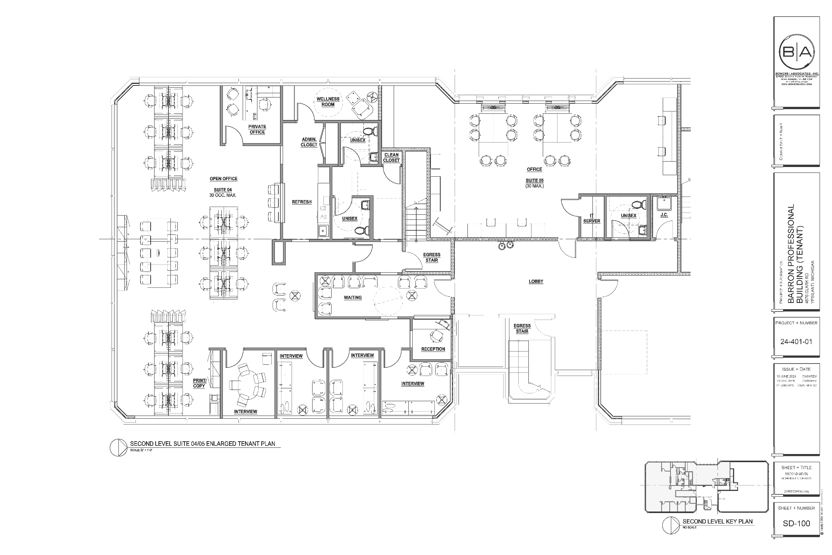
Exhibit B: Network Drop Locations
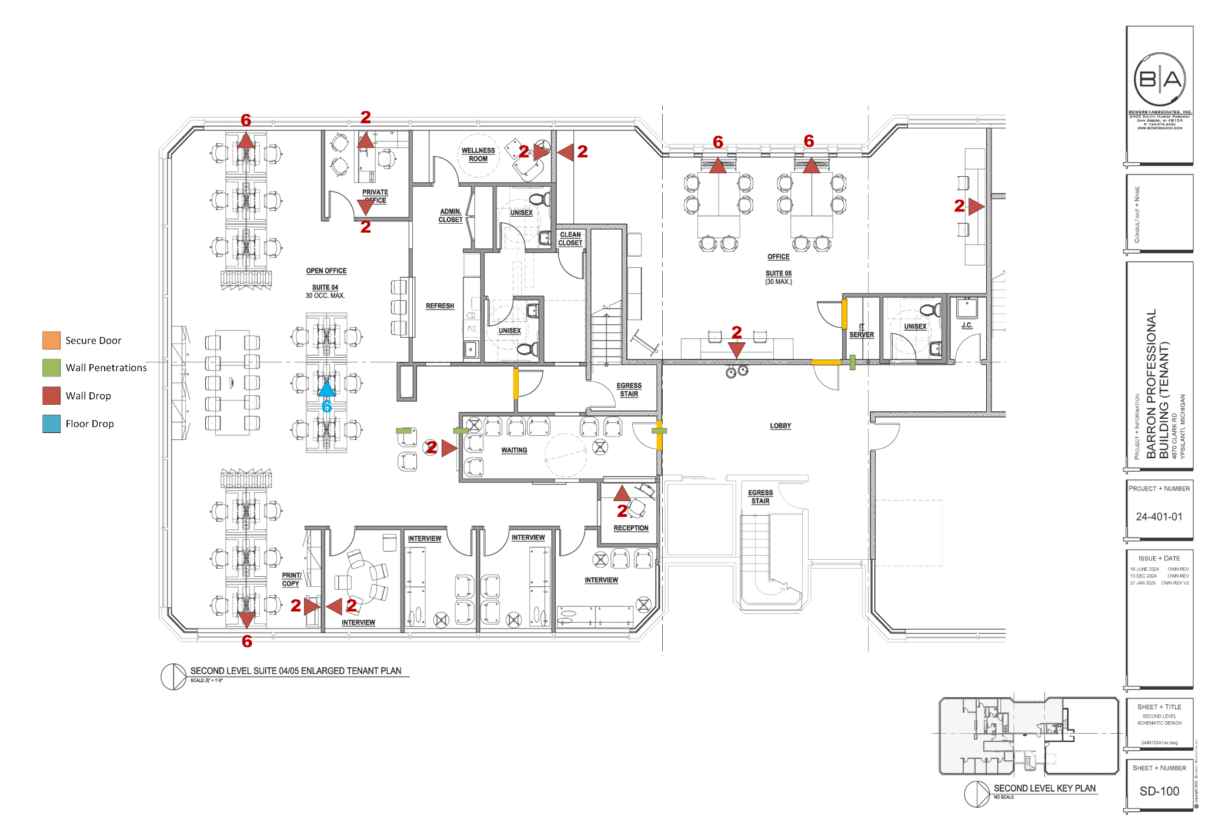
Exhibit C: Rough Dimensions
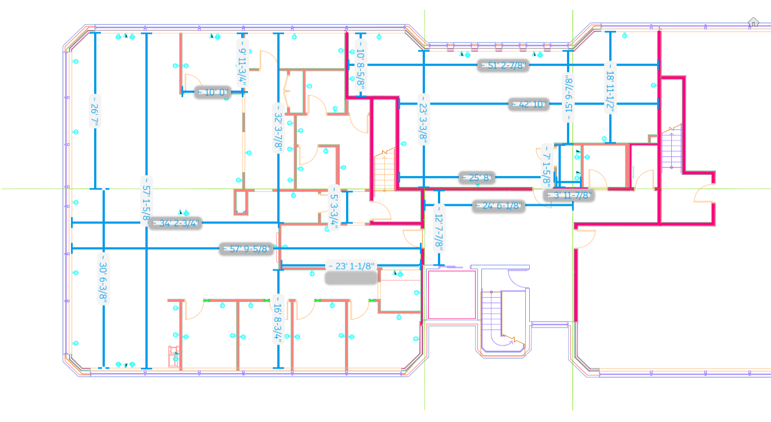
Note: Red walls are fire-rated walls

